Project: Highrise
Software Architecture Document

Version <1.0>

Table of Contents
1. Introduction 2
1.1 Purpose 2
1.2 Scope 2
1.3 Definitions, Acronyms, and Abbreviations 2
1.4 References 2
1.5 Overview 2
2. Architectural Representation 2
3. Architectural Goals and Constraints 2
4. Use-Case View 2
4.1 Use-Case Realizations 2
5. Logical View 2
5.1 Overview 2
5.2 Architecturally Significant Design Packages 2
6. Process View 2
7. Deployment View 2
8. Implementation View 2
8.1 Overview 2
8.2 Layers 2
9. Data View (optional) 2
10. Size and Performance 2
11. Quality 2

Software Architecture Document

Introduction
[The introduction of the Software Architecture Document provides an overview of the entire Software Architecture Document. It includes the purpose, scope, definitions, acronyms, abbreviations, references, and overview of the Software Architecture Document.]

Purpose
This document provides a comprehensive architectural overview of the system, using a number of different architectural views to depict different aspects of the system. It is intended to capture and convey the significant architectural decisions which have been made on the system.

[This section defines the role or purpose of the Software Architecture Document, in the overall project documentation, and briefly describes the structure of the document. The specific audiences for the document is identified, with an indication of how they are expected to use the document.]

Scope
[A brief description of what the Software Architecture Document applies to; what is affected or influenced by this document.]

Definitions, Acronyms, and Abbreviations
[This subsection provides the definitions of all terms, acronyms, and abbreviations required to properly interpret the Software Architecture Document. This information may be provided by reference to the project’s Glossary.]

References
[This subsection provides a complete list of all documents referenced elsewhere in the Software Architecture Document. Identify each document by title, report number (if applicable), date, and publishing organization. Specify the sources from which the references can be obtained. This information may be provided by reference to an appendix or to another document.]

Overview
[This subsection describes what the rest of the Software Architecture Document contains and explains how the Software Architecture Document is organized.]

Architectural Representation
[This section describes what software architecture is for the current system, and how it is represented. Of the Use-Case, Logical, Process, Deployment, and Implementation Views, it enumerates the views that are necessary, and for each view, explains what types of model elements it contains.]

Architectural Goals and Constraints
Our architecture is highly influenced by Godots architecture, which is based upon the event-driven architecture. All of our components are different versions of a “Node” which is the main component in Godot. Nodes can have other Nodes as children and throw events based on different scenarios, for example a click on something or a rerender.

Use-Case View
[This section lists use cases or scenarios from the use-case model if they represent some significant, central functionality of the final system, or if they have a large architectural coverage—they exercise many architectural elements or if they stress or illustrate a specific, delicate point of the architecture.]

Use-Case Realizations
[This section illustrates how the software actually works by giving a few selected use-case (or scenario) realizations, and explains how the various design model elements contribute to their functionality.]

Logical View
[This section describes the architecturally significant parts of the design model, such as its decomposition into subsystems and packages. And for each significant package, its decomposition into classes and class utilities. You should introduce architecturally significant classes and describe their responsibilities, as well as a few very important relationships, operations, and attributes.]

Overview
[This subsection describes the overall decomposition of the design model in terms of its package hierarchy and layers.]

Architecturally Significant Design Packages
[For each significant package, include a subsection with its name, its brief description, and a diagram with all significant classes and packages contained within the package.
For each significant class in the package, include its name, brief description, and, optionally, a description of some of its major responsibilities, operations, and attributes.]

Process View
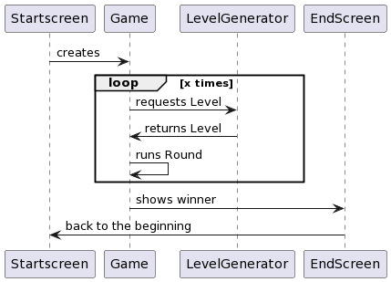

Deployment View
[This section describes one or more physical network (hardware) configurations on which the software is deployed and run. It is a view of the Deployment Model. At a minimum for each configuration it should indicate the physical nodes (computers, CPUs) that execute the software and their interconnections (bus, LAN, point-to-point, and so on.) Also include a mapping of the processes of the Process View onto the physical nodes.]

Implementation View

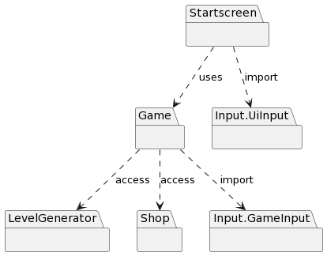
Our game will run on the device only, therefore we have no different subsystems. Our game will be organized in this package architecture.

Data View (optional)
[A description of the persistent data storage perspective of the system. This section is optional if there is little or no persistent data, or the translation between the Design Model and the Data Model is trivial.]

Size and Performance
[A description of the major dimensioning characteristics of the software that impact the architecture, as well as the target performance constraints.]

Quality
Our games quality will be heavily dependent on the users experience. Therefore we will focus on ease-of- use, provided by our simple architecture and straightforward interfaces.

